演讲题目 Title : Software design for resilient computer systems
演讲内容简介 Abstract:
Professor Igor Schagaev will addresses the question of how system software should be designed to account for faults, and which fault tolerance features it should provide for highest reliability. He first show how the system software interacts with the hardware to tolerate faults. His team analyze and further develop the theory of fault tolerance to understand the different ways to increase the reliability of a system, with special attention on the role of system software in this process. His team further develop the general algorithm of fault tolerance (GAFT) with its three main processes: hardware checking, preparation for recovery, and the recovery procedure. For each of the three processes, they analyze the requirements and properties theoretically and give possible implementation scenarios and system software support required. Based on the theoretical results, they derive an Oberon-based programming language with direct support of the three processes of GAFT. In the last part of the seminar, they introduce a simulator, using it as a proof of concept implementation of a novel fault tolerant processor architecture (ERRIC) and its newly developed runtime system feature-wise and performance-wise. The content applies to industries such as military, aviation, intensive health care, industrial control, space exploration, etc. · Outlines potential critical faults in the modern computer systems and what is required to change them · Explains how to design and re-design system software for the next generation of computers for wider application domains and greater efficiency and reliability · Presents how implemented system software support makes maintenance of computer systems much easier, while reliability and performance increases.

Brief Bio 简介
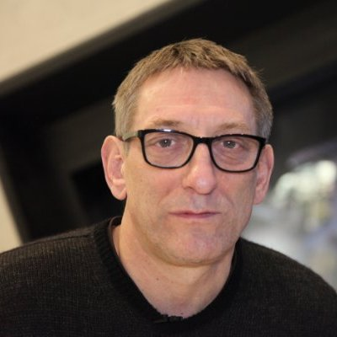
Professor Igor Schagaev, FIAP, FBCS,
Professor of University of Greenwich, London, UK
Director IT-ACS Limited, UK
Member of Institute of Control Sciences Russian Academy of Sciences

Professor Igor Schagaev received the degree of Engineer from Moscow Power Engineering Institute in 1977, PhD in Computer Science in 1987 from Institute of Control Sciences, Russian Academy of Science. Currently Igor is Professor of Computer Science of the University of Greenwich and Director of ITACS Ltd, UK. Igor’s current research interests are: evolving systems from concept and essential theory down to system design, computer architectures, system software as well as software engineering and active econometric monitor and self-evolving curriculum of computer science, the role of technology.

Igor and his team made an industrial product of active system safety see www.it-acs.co.uk/files/itacs_devices.pdf, prototype of evolving computer architecture 2014; he has published 60+ papers and six books. His most recent published work includes: Resilient Computer System Design (Springer 2015) and Software Design for Resilient Computers (Springer 2016) Active System Control - Resilient System Design (Springer 2017).

Professor Schagaev holds the patent on “Method of active conditional control”: http://www.it-acs.co.uk/files/GB2448351B.pdf now known as “health monitoring systems”. Igor was scientific leader of ONBASS project (Grant of FP6 EC 2004-08), author of Evolving Reconfigurable Architecture approach; as well as graph-logic model - new methods of real-time diagnostic and recovery for complex objects .

Igor worked, collaborated and also provided his expertise as consultant to corporations and government agencies, including:
Sukhoy Design Bureau on avionics 1991-1995
Boeing 1998-1999
Airbus 2006
Sweden Government on efficiency of research programs -2014

