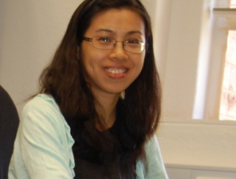
Lili Wei (Associate Professor, Institute of Urban Environment, Chinese Academy of Sciences)

Dr. Lili Wei holds a PhD in Ecology (with emphasis on physiological ecology of mangroves). After five years working at The University of Queensland and Griffith University in Australia, her research has branched out into broader areas in plants, soils and water sources as well as their interactions. Her current research interests focus on the functions of coastal wetlands in response to human disturbances. She is also interested in functional biodiversity especially when the environment changes. Her publications include 2 book chapters and over 20 original papers in peer reviewed journals.

韦莉莉
中国科学院城市环境研究所 副研究员

拥有生态学专业博士学位（厦门大学）和五年的博士后研究经历（澳大利亚昆士兰大学和格里菲斯大学）。研究范围因而得以扩展，从植物生理生态到土壤生态到水资源利用等。目前的研究主要关注人为干扰条件下（如城市化、污染、富营养化等）海岸带湿地的生态功能。另外，研究兴趣还包括生态系统的功能多样性及其与物种多样性的差异，尤其在环境变化条件下。目前已发表20多篇学术论文，其中以第一作者发表SCI论文10余篇并已被Nature等期刊引用。

