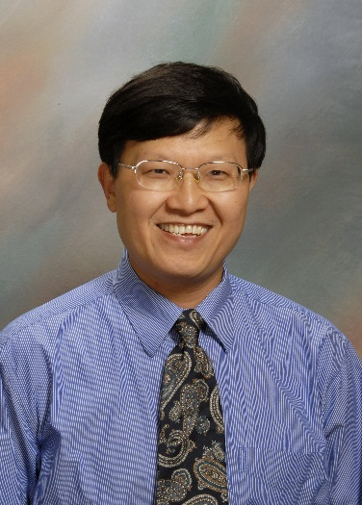
Human-Robot Collabrative Learning of Human Welder Intelligences
YuMing Zhang, PhD
Professor and James Boyd Professor of Electrical Engineering
University of Kentucky, Lexington, Kentucky, USA

A major challenge in learning human welder intelligence arises from the specular nature of pool surface that disqualifies diffuse reflection-based laser triangulation methods. To overcome this issue, the mirror surface is advantageously used to reflect a laser pattern away from the arc, simultaneously eliminating the arc illumination problem. To allow welders to freely demonstrate their skills, a human-robot collaborative system has been established where a welder carries a virtual torch, similarly as operating an actual one, without a sensor. The movement is measured at the virtual system and then followed by a robot which carries the sensor and performs the actual welding. The measured weld pool is displayed to the operator at the virtual site such that the welder can observe the change in the operation result to adjust his/her torch movement and other parameters. The true intelligence of the welder is thus contained in and can thus be extracted from the resultant data. To further extend the ability to unconfined environments, an ultra-compact inertial measurement unit (IMU) has been attached to a manually operated torch to monitor its movement and orientation. To ensure the ultra-high precision needed, a foundation has been established to self adaptively cross calibrate the sensors.

Biography:
YuMing Zhang has been with the University of Kentucky, Lexington, Kentucky, USA since 1991. His research in innovative welding processes, sensing and control of welding processes, and intelligent and robotic welding has brought him 189 peer-reviewed journal publications, 9 US patents, and recognitions from The Institution of Mechanical Engineers of the United Kingdom, International Federation of Automatic Control (IFAC), American Welding Society (AWS), and University of Kentucky College of Engineering. Four of his PhD students received the Henry Granjon Prize from the International Institute of Welding (IIW). He is currently the Chairman of the AWS Technical Papers Committee and a Lead Principal Reviewer of the Welding Journal. He is also an Associate Editor for the Journal of Manufacturing Processes, a former Associate Editor of the IEEE Transactions on Automation Science and Engineering, and an Editor-in-chief of the Transactions of Intelligent Welding Manufacturing. He has been elected to Fellow of the AWS, ASME, and SME.

